Academic Year: 2025-26 | Year: Second Year | Semester: II
PRN No.: 1012411011 | Name: Riddhee Kulkarni
Subject: Python Programming
Assignment No.: 4
Date: 22/12/2025

Lab Assignment: 04
Aim:
To write a Python program to perform addition, subtraction, multiplication, and division. The program accepts input from the user and performs the operation accordingly.

Objective:
To understand and implement basic arithmetic operations using Python.
To accept user input for numbers and operators.
To use conditional statements (if-elif-else) to perform different operations based on user choice.
To handle errors such as division by zero and invalid operator input.

Theory:
A calculator program takes two numbers and an operator as input.
Depending on the operator (+, -, *, /), it performs the corresponding arithmetic operation.
Python uses if-elif-else statements to make decisions based on user input.
Division by zero is handled using a conditional check.

Algorithm:
- Start the program.
- Input the first number a and the second number b.
- Input the operator o.
- If o is +, perform addition.
- Else if o is -, perform subtraction.
- Else if o is *, perform multiplication.
- Else if o is /, check if b is not zero and perform division. Otherwise, display an error.
- Else, display “Invalid Operator”.
- Stop the program.

Pseudo Code:
START
READ a, b
READ operator o
IF o == '+'
PRINT a + b
ELSE IF o == '-'
PRINT a - b
ELSE IF o == '*'
PRINT a * b
ELSE IF o == '/'
IF b != 0
PRINT a / b
ELSE
PRINT "Cannot divide by zero"
ELSE
PRINT "Invalid Operator"
END

Code:
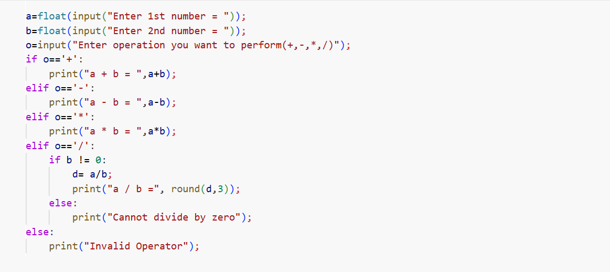

Output:
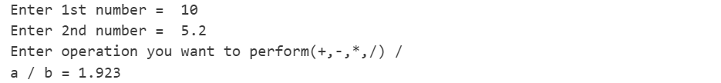

Conclusion:
The program successfully performs addition, subtraction, multiplication, and division based on the operator entered by the user. It demonstrates the use of conditional statements, user input handling, and basic arithmetic operations in Python. The program also ensures error handling by checking for division by zero and invalid operators, making it reliable and user-friendly.

